SOP #9 - Animal Health Practices and Branding
(Question AC11, July 2023 Reference Manual pages 4-3 to 4-5. All shaded areas are required elements of your SOP. You may use your own words to communicate the same intent.)
Purpose: All farm personnel responsible for performing animal health practices, such as disbudding/dehorning, castration and supernumerary teat removal, and branding (if applicable) must understand how to complete those processes effectively and efficiently while minimizing stress to the animals.

- On this farm we will ensure that any animal health procedures administered to animals under our ownership and/or care will be done in a humane manner with efforts to reduce stress and mitigate pain while ensuring safety.
- The persons who will perform animal health procedures are: ____________, ____________, and/or other persons as delegated from time to time by either the owner or herdsperson.
- All persons handling cattle will be trained in the safe, humane and effective handling of cattle.
- Prior to any procedures, pain control products will be administered.
- Pain control products, amounts and injection techniques have been reviewed with the veterinarian.
Pain Medication Types:
Anesthesia - Causes loss of sensation surrounding the site of injection. Effective in reducing immediate pain up to 2-3 hours after administration (ex. Lidocaine)
NSAID - Reduces pain and associated stress responses from 30 mins up to 24 hours after administration. (ex. Meloxicam, Ketoprofen)
Sedation - Provides analgesia for 15-30 minutes, and sedation for up to 2 hours (ex. Rompun (xylazine), Tramadol)

Disbudding/Dehorning (Identify method used)
- We do not disbud or dehorn because all calves have polled genetics.

OR

- The calf will be properly and safely restrained using a halter tied short to a solid post, lying down with legs restrained, or calf squeeze.
- Hot Iron Method:
  - Before disbudding, administer immediate pain control by injecting ______cc of local anesthesia (i.e. Lidocaine) into the corneal nerve on each side using a new 20 gauge x 1.5” needle for each animal.
  - Before the procedure, each animal will be given ____ cc of NSAID (non-steroidal anti-inflammatory i.e. Metacam) for post procedure pain control.
  - Ensure immediate pain control is effective by observing the animal.
  - Once the immediate pain control is effective calves will be disbudded with an electric/propane dehorner or heated steel dehorner.
  - Ensure the iron is hot enough. The iron will be hot enough once it is red in colour.
  - Apply the iron over the horn. Gently press and rotate the iron for ______sec. Remove the iron. Look for a copper coloured ring around the base – if not reapply the iron for ______sec. DO NOT HOLD THE IRON ON LONGER THAN NECESSARY.
  - Using your thumb flip the horn cap off.
  - In case of bleeding the hot iron will be used to cauterize the wound to control bleeding.
- Caustic Paste Method:
  - Before disbudding, administer immediate pain control by injecting ______cc of local anesthesia (i.e. Lidocaine) into the corneal nerve on each side using a new 20 gauge x 1.5” needle for each animal.
  - Before the procedure, each animal will be given ____ cc of NSAID (non-steroidal anti-inflammatory i.e. Metacam) for post procedure pain control.
  - Ensure immediate pain control is effective by observing the animal.
  - Once the immediate pain control is effective calves will be disbudded.
  - Pull hair back from around horn bud, apply paste to horn bud, and move hair back over horn bud.
- Post procedure pain management will be monitored by watching calves for signs of head shaking, ear flicking, reduced activity level and/or reduced feed or water intake.
  - If any of these behaviors are identified re-treatment with _______ cc of NSAID will be administered.
- Medications administered will be recorded in ___________________. Information includes: product name, amount, injection technique, withdrawal times and clear dates.

Castration (Identify method used)
- We do not castrate any on farm.

OR

- The calf will be properly and safely restrained using a halter tied short to a solid post, lying down with legs restrained, or calf squeeze.
- Before beginning the procedure, we will administer pain control:
  - We castrate at the same time as dehorning/disbudding; or
  - ______ cc of anesthetic (ie. Lidocaine) will be injected into each teste for immediate pain management; and/or
  - _______ cc of NSAID (ie. Metacam) for pain management.
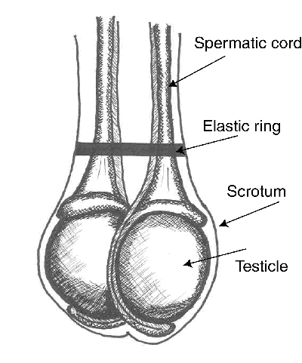
- Elastrator Method:
  - Prepare the elastrator by placing the band on the plier claws/spreader tips.
  - Hold elastrator in one hand. With the other hand grasp the scrotum and both testes to ensure they are descended.
  - Holding the cord above the testes, stretch open the band with the pliers.
  - Apply the band around and over the testes below the other hand. For calves > 3 weeks a second band will be applied.
Ensure that bands are stored as indicated and new stock purchased regularly. Improperly stored and/or old bands lose their effectiveness and can fail causing pain and health issues.

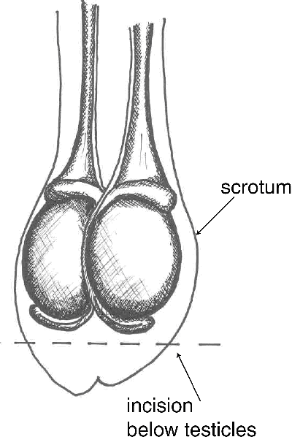
- Surgical Method:
  - Palpate scrotum to ensure both testes are descended.
  - Cut and remove the bottom of the scrotum.
  - Grasp the testes one at a time and gently and firmly pull them through the incision, breaking or cutting the cord.
- Post procedure pain management will be monitored by watching calves for signs of kicking, abnormal stance, reduced activity level and/or reduced feed or water intake.
  - If any of these behaviors are identified re-treatment with _______cc of NSAID will be administered.
- Medications administered will be recorded in ___________________. Information includes: product name, amount, injection technique, withdrawal times and clear dates.

Supernumerary Teat Removal
- We do not remove extra teats on farm.

OR

- The calf will be properly and safely restrained using a halter tied short to a solid post or calf squeeze.
- Each animal will be given _______ cc of NSAID for post procedure pain management.
- We remove extra teats at the same time as dehorning/disbudding.
- Amputate teat with surgical scissors or a scalpel blade.
- Post procedure pain management will be monitored by watching calves for signs reduced activity level and/or reduced feed or water intake.
  - If any of these behaviors are identified re-treatment with _____cc of NSAID will be administered.
- Medications administered will be recorded in ___________________. Information includes: product name, amount, injection technique, withdrawal times and clear dates.

Branding
- We do not brand on farm.

OR

- The animal will be properly and safely restrained using a halter tied short to a solid post.
- Before beginning the procedure, we will administer pain control.
  - ______ cc of anesthetic (ie. Lidocaine) will be administered at the location to be branded for immediate pain management; and/or
  - _______ cc of NSAID (ie. Metacam) will be administered.
- Freeze Branding:
  - Animals will be freeze branded using a solution of dry ice and isopropyl alcohol.
  - Submerge the brass irons in the solution for _______ minutes until they have reached the correct temperature.
  - Prepare the area to be branded by trimming the hair as short as possible, brushing away any loose hair or debris, and spraying with isopropyl alcohol.
  - Apply the iron to the area. Firmly press and slightly rock the iron for _____ seconds.
  - Remove the iron. Look for the brand shape to be visibly marked – if not reapply the iron for _____ seconds.
- Hot Branding:
  - Animals will be branded using an electric iron or heated steel iron.
  - Ensure the iron is hot enough. The iron will be hot enough once it is red in colour.
  - Apply the iron to the brand area. Gently press the iron for _______ seconds.
  - Remove the iron. Look for a copper coloured mark where the brand was applied – if not reapply the iron for _______ seconds. DO NOT HOLD THE HOT BRAND ON LONGER THAN NECESSARY.
- Post procedure pain management will be monitored by watching animals for signs of reduced activity level and/or reduced feed or water intake.
  - If any of these behaviors are identified re-treatment with _____cc of NSAID will be administered.
- Medications administered will be recorded in ___________________. Information includes: product name, amount, injection technique, withdrawal times and clear dates.

