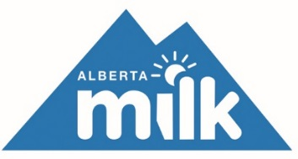Agenda – For Industry

2019 Fall Producer Meetings

Morning Closed for Producers Only

Noon Lunch
(Voting for delegates will occur over the lunch hour)

12:50 p.m. Presentation of the 2018-19 Milk Quality Certificates

1:00 p.m. Alberta Milk Chairman’s Remarks – Tom Kootstra
(Trade WMP, DFC)

1:30 p.m. Industry Update – Mike Southwood
(Production and Quota, Milk Quality, Animal Health, Research)

2:15 p.m. Open Discussion

3:00 p.m. Adjournment

Corporate Sponsor and Partner

