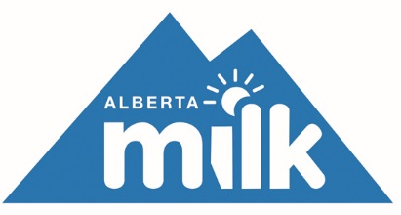
2018 Spring Producer Meetings

Agenda

9:30 a.m. Registration

10:00 a.m. Call to Order
Introductory remarks from region chair

10:15 a.m. Alberta Milk Chairman’s Opening Remarks – Tom Kootstra
(Producer Liability Insurance, Trade, WMP, DFC Update)

10:45 a.m. Industry Update – Mike Southwood
(Production and Quota Position, Milk Quality, Animal Health, DFC Nutrition and Marketing Update, Research)

Noon Lunch

1:00 p.m. WCB Update – Boris Makale

1:30 p.m. Policy Update– Tom Kootstra
(Regulations review, Quota Administration)

2:30 p.m. General Discussion

3:00 p.m. Adjournment

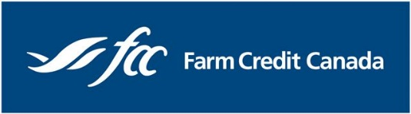
We would like to thank Farm Credit Canada, an Alberta Milk corporate sponsor, for sponsoring the producer meeting coffee breaks.

