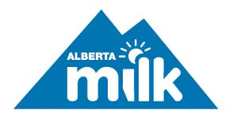
2017 Dairy Conference
Standing United
November 22, 2017 | Fantasyland Hotel

8:00 – 9:00 am Registration and Breakfast

9:00 – 9:15 am Tom Kootstra, Chairman of the Alberta Milk Board
Welcome and Opening Remarks

9:15 – 9:30 am Dan Wong and Ann Landers
Western Dairy Council Address

9:30 – 10:45 am Session 1: Tony Chapman
Stop selling your story. Become Part of Mine.

10:45 – 11:15 am Dairy Break

11:15 – 12:15 pm Session 2: Herman Barkema, University of Calgary Veterinary Medicine
Antimicrobial use / resistance

12:15 – 1:00 pm Lunch

1:00 – 1:15 pm Alberta Milk/Alberta School Athletic Association Scholarship presentation
Provincial Quality Milk Award presentation

1:15 – 2:15 pm Session 3: Peter Kuperis, Alberta Agriculture and Forestry
Navigating Changes in Trade

2:15 – 2:45 pm Dairy Break

2:45 – 3:45 pm Session 4: Jennifer Jones
DFC’s Fuelling Women’s Champions

6:00 pm Banquet
Welcome from the Minister of Alberta Agriculture and Forestry
Recognition of Service Award
Recognition of Outgoing Directors
Entertainment: Sheldon Casavant, Interactive Magic

